Customer Shopping Behavior Analysis

- Project Overview
The rapid growth of e-commerce and digital retail platforms has generated vast volumes of customer transaction data. Analyzing this data enables organizations to understand customer preferences, spending habits, and purchasing behavior, which are critical for data-driven decision-making.
This project focuses on analyzing customer shopping behavior using a transactional dataset containing 3,900 purchase records across multiple product categories. The primary objective is to extract meaningful insights related to customer demographics, spending patterns, product preferences, discount usage, and subscription behavior. The insights derived from this analysis can help businesses improve marketing strategies, enhance customer retention, optimize pricing policies, and increase overall revenue.
The project follows an end-to-end analytics workflow involving Python for data preprocessing and exploratory analysis, SQL for business-focused queries, and Power BI for interactive data visualization.
- Dataset Summary
The dataset used for this analysis represents customer purchase transactions collected from a retail shopping platform.
Dataset Characteristics
- Total Rows: 3,900
- Total Columns: 18
Key Features
- Customer Demographics
  - Age
  - Gender
  - Location
  - Subscription Status
- Purchase Details
  - Item Purchased
  - Product Category
  - Purchase Amount
  - Season
  - Size
  - Color
- Shopping Behavior
  - Discount Applied
  - Promo Code Used
  - Previous Purchases
  - Frequency of Purchases
  - Review Rating
  - Shipping Type
Data Quality
- Missing Values:
  - 37 missing values identified in the Review Rating column.
- Overall Data Condition:
  - No duplicate records.
  - Numeric and categorical variables were well-distributed for analysis.
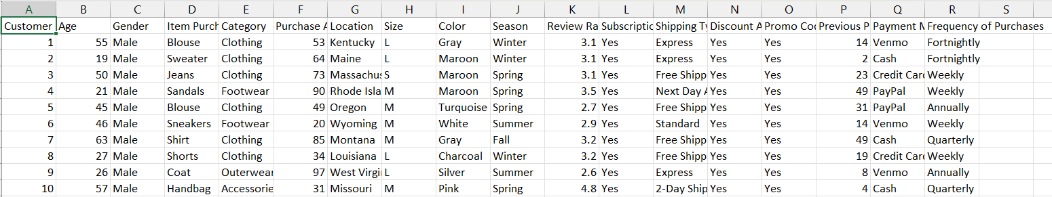

3.Exploratory Data Analysis using Python
We began with data preparation and cleaning in Python:
    - Data Loading: Imported the dataset using pandas.
    - The dataset was loaded using the pd.read_csv() function.
    - Initial exploration was performed using:
      - df.head() to view sample records
      - df.info() to understand data types and null values
      - df.describe() to analyze summary statistics

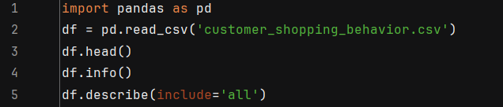

Handling Missing Data
- The Review Rating column contained missing values.
- These missing ratings were imputed using the median review rating within each product category, ensuring category-level consistency and avoiding bias.
Column Standardization
- Column names were converted to snake_case format to:
  - Improve readability
  - Maintain consistency across Python, SQL, and Power BI
  - Enhance documentation and collaboration
Feature Engineering
To enrich the dataset, new variables were created:
- Age Group:
  - Customers were grouped into age brackets (e.g., 18–25, 26–35, 36–45, etc.) for demographic analysis.

- Purchase Frequency (Days):
  - Derived from purchase-related data to analyze customer buying frequency.
Data Consistency Checks
- The columns discount_applied and promo_code_used were examined for redundancy.
- Since both conveyed similar information, promo_code_used was removed to avoid duplication.
Database Integration
- The cleaned and processed dataset was connected to a MySQL database.
- Python scripts were used to load the final DataFrame into the database, enabling structured SQL-based analysis.
4. Data Analysis using SQL (Business Transactions)
We performed structured analysis in MySQL to answer key business questions:
1. Revenue by Gender – Compared total revenue generated by male vs. female customers.
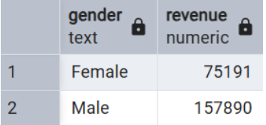

2.High-Spending Discount Users – Identified customers who used discounts but still spent above the average purchase amount.
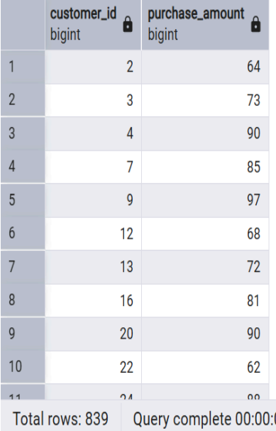
- Top 5 Products by Rating – Found products with the highest average review ratings.
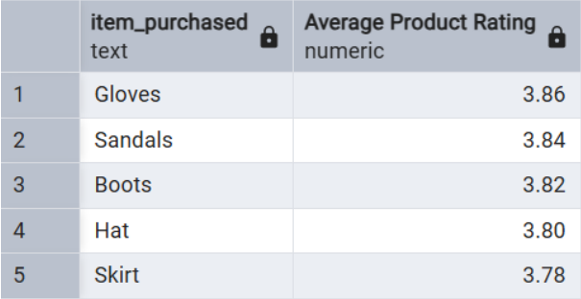
- Shipping Type Comparison – Compared average purchase amounts between Standard and Express shipping.
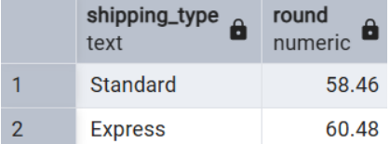
- Subscribers vs. Non-Subscribers – Compared average spend and total revenue across subscription status.
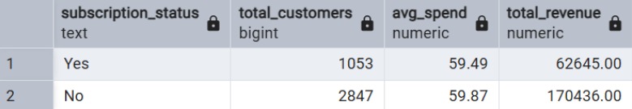
- Discount-Dependent Products – Identified 5 products with the highest percentage of discounted purchases.
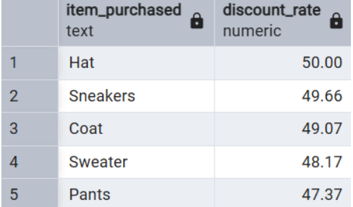
- Customer Segmentation – Classified customers into New, Returning, and Loyal segments based on purchase history.
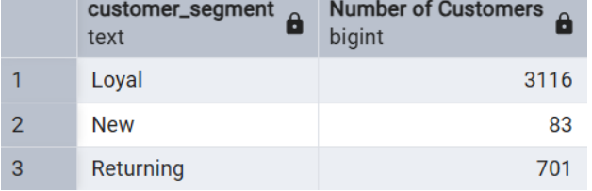
- Top 3 Products per Category – Listed the most purchased products within each category.
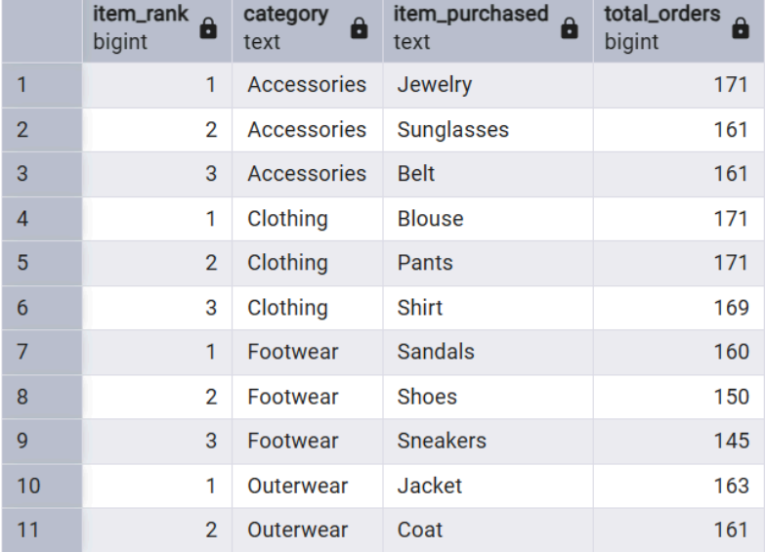
- Repeat Buyers & Subscriptions – Checked whether customers with >5 purchases are more likely to subscribe.
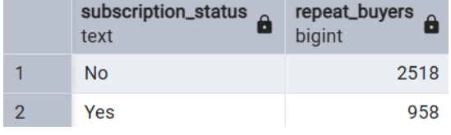
- Revenue by Age Group – Calculated total revenue contribution of each age group.
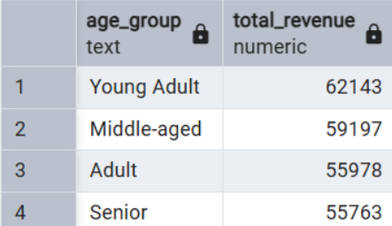
5. Dashboard in Power BI
An interactive dashboard was created using Power BI to visually communicate insights
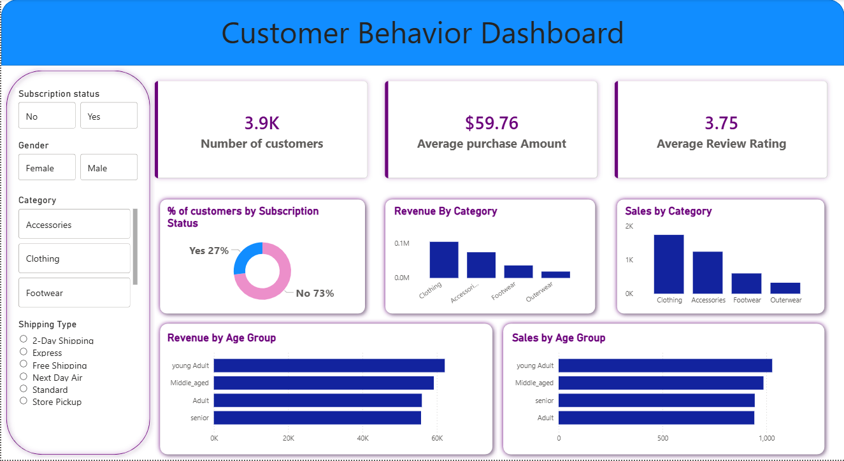
Dashboard Features
- Revenue distribution by gender and age group
- Subscription vs. non-subscription spending comparison
- Product category performance
- Discount impact analysis
- Customer segmentation overview
- Shipping type and purchase amount analysis
6. Business Recommendations
● Boost Subscriptions – Promote exclusive benefits for subscribers.
● Customer Loyalty Programs – Reward repeat buyers to move them into the “Loyal” segment.
● Review Discount Policy – Balance sales boosts with margin control.
● Product Positioning – Highlight top-rated and best-selling products in campaigns.
● Targeted Marketing – Focus efforts on high-revenue age groups and express-shipping users.

